**Experiment 22**

**Lab Book:**

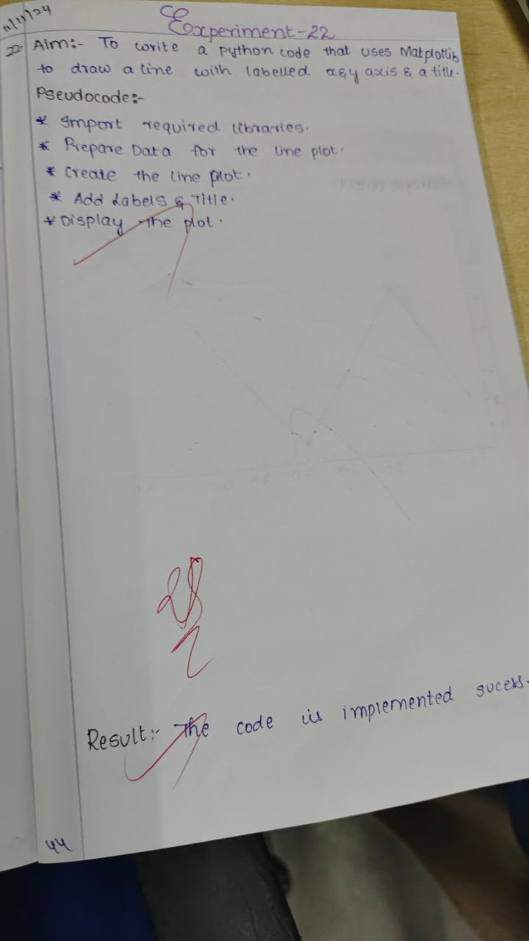

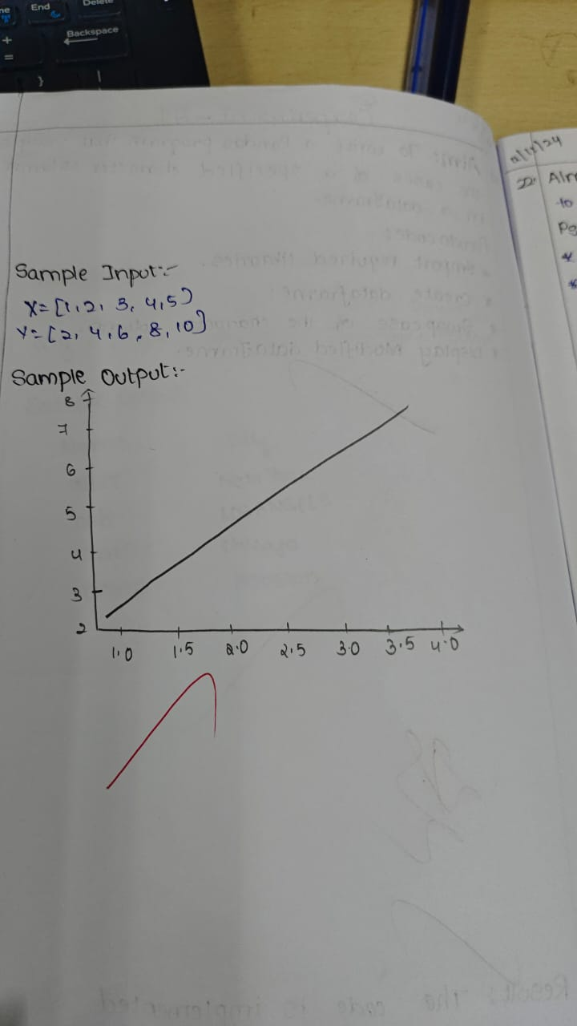

**Code:**

import matplotlib.pyplot as plt

x = [1, 2, 3, 4, 5]

y = [2, 4, 6, 8, 10]

plt.plot(x, y, label='Line Plot', color='blue')

plt.xlabel('X Axis Label')

plt.ylabel('Y Axis Label')

plt.title('Simple Line Plot')

plt.legend()

plt.show()

**Sample Output**

